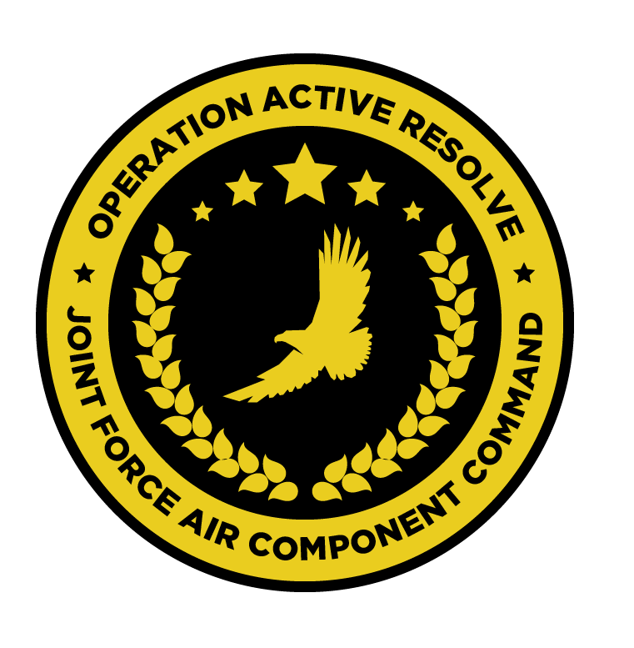

JFACC AIR OPERATIONS DIRECTIVE

OPERATION ACTIVE RESOLVE 2

D5

# 1. SITUATION

## a. JFC guidance (verbatim).

Priority of effort is on establishing Air Superiority in support of LCC and set conditions

for own operations.

* Start shaping for phase 2 in the operation (Create permissive environment).
* Continue support to LCC
* Be prepared to prepare contingency plans for striking Syrian WMD at short notice (regardless of phase). Expect this plan to be asked for prior to commencing phase 2. ALR: HIGH approved for such a plan.

## b. Enemy situation.

The current enemy situation is defined in VIS INTSUM D5, available at OPAR BRIEF.

## c. Friendly situation (by joint force component).

### Land Component Command (LCC)

#### IV Corps

The 55th Mechanized Division has secured HATAY and have moved forward battalions to screening positions along the FLOT.

The 56th Armor Division has its’ forward elements at the outskirt of Gaziantep. The 56th is preparing for the assault at Gaziantep airfield that will commence in the morning hours of D?.

#### Turkish local forces

The Turkish 33rd Brigade protecting the Ataturk Dam have been defeated by Syrian

forces despite heavy resistance and support from JFACC with CAS. They have withdrawn to the city of Sanliurfa in order to prevent Syrians capturing the airfield.

* Turkish local forces are in static defensive positions and are not in a position to assume offensive operations.
* Turkish local forces consist of BTR-80 and M-113s vehicles
* Turkish local forces are reinforced with coalition JTACs to support with CAS to defend
* against Syrian attacks.

### Maritime Component Command (MCC)

CSG-1 continues to support the mission from CSG-1 operations box.

SAG 1 remains outside the AO, having been directed to support shipping movements elsewhere.

### Special Operations Component Command (SOCC)

SOF teams are standing by to support with reconnaissance as required and requested by JFACC.

* Three SOF teams were inserted into theatre in support of the observation of strategic objectives.

# 2. MISSION - The JFACC’s mission statement (verbatim).

JFACC will establish air superiority in the area of operations and defeat Syrian offensive capability in support of CJTF-82’s offensive operations to neutralize Syrian offensive capability to conduct offensives in the region.

# 3. EXECUTION – AIR OPERATIONS

|  |  |
| --- | --- |
| **JFACC’s Intent**   1. **Purpose** 2. **End State** | JFACC’s intent for this day is to focus operations on Gazientep and Minakh in order to:   * Significantly attrit rocket artillery (MLRS) units at Gaziantep and Minakh in order to shape the conditions for the land assault. * Destroy the HQ observed at Minakh AB in order to reduce effective C2 of syrian 2nd corp forces. * Attrit 11th mechanized division at Gazientep by destroying IFVs and artillery units. * Destroy both Syrian Army HQ buildings in Aleppo in order to reduce Syrian army offensive C2 and mobilisation efforts. * Destroy the Kerosene and/or IRFNA fuel tanks at the 922nd SCUD regiment base and the rocket fuel factory at Aleppo in order to prevent the 922nd SCUDs to reach launch readiness. * Backup targets will be specified per ATO.   Current status of attrition of syrian 1st and 2nd corps forces is as follows:  MLRS units, at best 50%, 75% needed  IFVs and artilllery units, at best 9%, 20% needed for IFVs and 50% for artillery units. For IFVs it means destruction of about 50 units, Artillery around 45 units.  The end state of this ATO sees the significant attition of Syrian army units at Gazientep and Minakh up to and over the required percentage of attrition. Both HQ building at Aleppo as well as the HQ at Minakh AB destroyed.  The destruction of the fuel and/or IRFNA oxidiser tanks as well as the production and storage building. |
| **Execution** What to do, when. – Any detailed instructions if needed | Flights will be tasked to engage MLRS, IFV and Artillery units IVO of Gazientep and Minakh AB. SEAD/DEAD flights will support both killboxes. Significant effort will be required to suppress and/or destroy the remaining SA-15s in both killboxes.  Due to adverse weather and lack of 500lbs GPS guided munitions, flights will use a combination of larger GPS guided warheads as well as laser guided munitions. For KB BC, JTACs GRUMPY, HUNTER, LAZYCAT and CANDYMAN are standing by to lase targets, further coordination with the LCC.  KB CB has no active JTACs at this point in time.  Flights will use SCAR in killboxes BC and CB to prosecute targets.  For Gazientep, KB BC will be used, overflying KB BB/BD to the west and east of BC is approved.  SEAD/DEAD flight will support the killboxes and will not be SCAR. First flight in the Killbox will be SEAD/DEAD, followed by the SCAR flights.  For Minakh AB, KB CB will be used, overflying KB CA/CC to the west and east of CB is approved. Initial routing to KB CB is via KB BB.  The above mentioned flights will have a CAP flight (FL240 and above) overhead for the duration of their mission.  A package of flights will be tasked separately to undertake the strike on the two HQ buildings, [SYTGT001](https://raw.githubusercontent.com/132nd-vWing/OPAR-Brief/master/INTELLIGENCE/TGT_FOLDERS/SYTGT001_Syrian_Army_HQ_building1.pdf) and [SYTGT002](https://raw.githubusercontent.com/132nd-vWing/OPAR-Brief/master/INTELLIGENCE/TGT_FOLDERS/SYTGT002_Syrian_Army_HQ_building2.pdf), at Aleppo. This package will contain Strike, SEAD and Sweep/Escort flights.  The package will rendez-vous at ACP CHICAGO at 2000z, Package lead will push from there.  Another package will strike [SYTGT003](https://raw.githubusercontent.com/132nd-vWing/OPAR-Brief/master/INTELLIGENCE/TGT_FOLDERS/SYTGT003_922nd_SCUD_regiment_base.pdf) KT target with 500lbs bombs as well as SYTGT137 with priority on targets A, B, F and G. Targets C, D and E are to be attacked weight permitting. This package will contain Strike, SEAD and Sweep/Escort flights.  Backup target is SYTGT020  The package will rendez-vous at ACP DORTMUND at 2000z, Package lead will push from there.  Additional flights may be tasked with CAP, SWEEP or SEAD depending on sign-up. |
| **Focus of effort by objective** | In accordance with JFACC objectives (JAOP) 3.2.1.3 and 3.2.2.1, this AOD predominantly seeks to reduce the number of MLRS, IFV and artillery units situated IVO Gazientep and Minakh AB. The majority of sorties in this both ATOs will be directed in support of this objectives.  Additional sorties will be allocated to strike the two HQ buildings at Aleppo as well as the SCUD regiment base and rocket fuel factory. |
| **Acceptable level of risk**. (including for AWACS and tankers: forward or rear) | As per SPINS |
| **Collateral damage and civilian casualty guidance** | Every attempt should be taken to minimise collateral damage in the execution of these missions.  Suspected civilian casualties should be reported as soon as is practicable. |
| **TST guidance** | Where they are identified, items from the TST matrix must be prosecuted. The outcome should be reported on the in-flight report net. If prosecution is not possible, the location must be reported for re-tasking.   |  |  |  |  |  |  | | --- | --- | --- | --- | --- | --- | | **PRIORITY** | **TARGET** | **DESIRED EFFECT** | **RISK LEVEL** | **STATUS** | **RMKS** | | 1 | SCUD | Destroy | MEDIUM | Unlocated | N/A | | 2 | Fuel truck ATZ-10 | Destroy | MEDIUM | Likely SYTGT003/137 |  | |
| **Intelligence, Surveillance, Reconnaissance (ISR)** – If any effort should be done to support VIS with ISR to answer information gaps from VIS. | All intelligence and BDA should be submitted via Campaign Manager, and necessary images placed in #bda-reports on discord IAW SPINS.  The following IRs should be supported in this AOD:   1. (IR35.1) Are there SA-6 or SA-11 within 50km of the FLOT? If so, where? 2. (IR35.5) How many SA-15s/SA-8s are located at Gaziantep? 3. (IR35.6) How many SA-15s/SA-8s are located at Minakh? 4. (IR35.10) Are any SA-15s/SA-8s located within 50km of the FLOT but not IVO south of Hatay, Taftanaz, Minakh, Gaziantep or Birecik Dam? 5. (IR35.13) Are there enemy SAMs located IVO Aleppo Intl? 6. (IR35.14) Is any enemy rotary wing activity observed within 200km of FLOT? 7. (IR35.15) Is any fixed wing activity observed into or out of front-line airfields (Kharab Ishk, Aleppo Int, Kuweires, Tal Siman?   All VIS/VID Information Requests can be found here. |
| **Other issues** | The use of GBU-38s is limited to SEAD/DEAD flights. |
| **Direction and Guidance** | Aircrews must remain clear of Jordanian airspace at all times. Munitions must not be expended which may encroach on Jordanian airspace.  Munitions may not be expended in the direction of Basel Al Assad And Tartarus in order to avoid Russian involvement in the conflict. |

# 4. ADMINISTRATION AND LOGISTICS

Due to other ongoing major military operations, the munitions are limited in accordance with the ‘available ordnance’ publication available at OPAR Brief. **Further limitations may be imposed by JFACC and will be detailed in the ATO.**

**Active Tanker Tracks –** AR701 (ARCO-1), AR803 (SHELL-3) and AR804 (SHELL-4) as published in D5 ACO

# 5. COMMAND AND CONTROL

BULLSEYE NICOLE is defined at N 35 58.000 E 036 47.000.

There are no other specific C2 considerations for these missions. Refer to the Command, Control and Communications section of the JAOP.